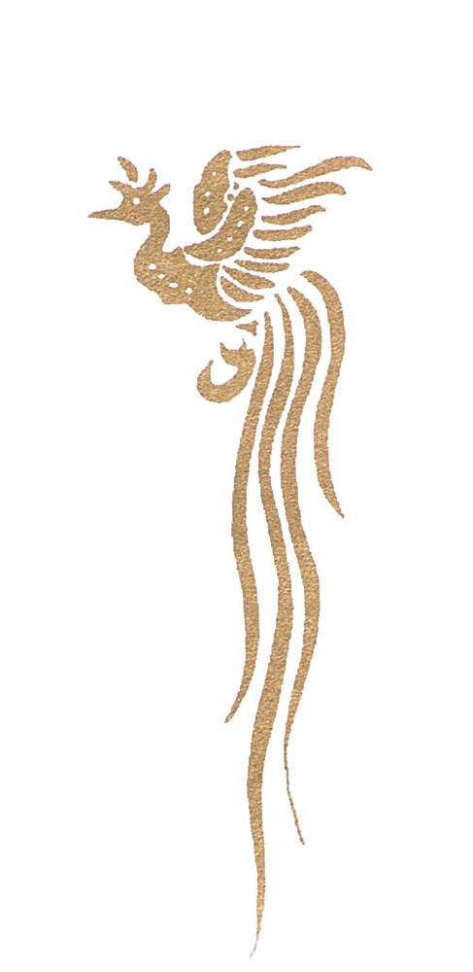
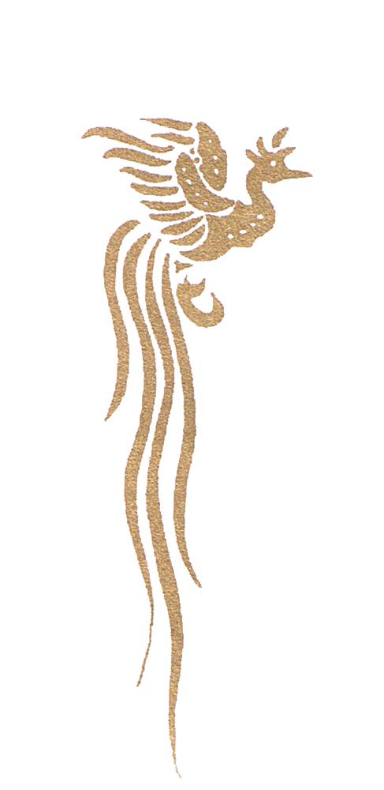

ITALIAN KYOKUSHIN ORGANIZATION

VIA MOSCATELLI, 113
74027 SAN GIORGIO JONICO (TA) – ITALIA
Tel/Fax: 099 592 58 00
e-mail: oyamafitnessclub@libero.it

Dear Shihan, Sensei, Senpai,

I hope that this letter will find you in good health.

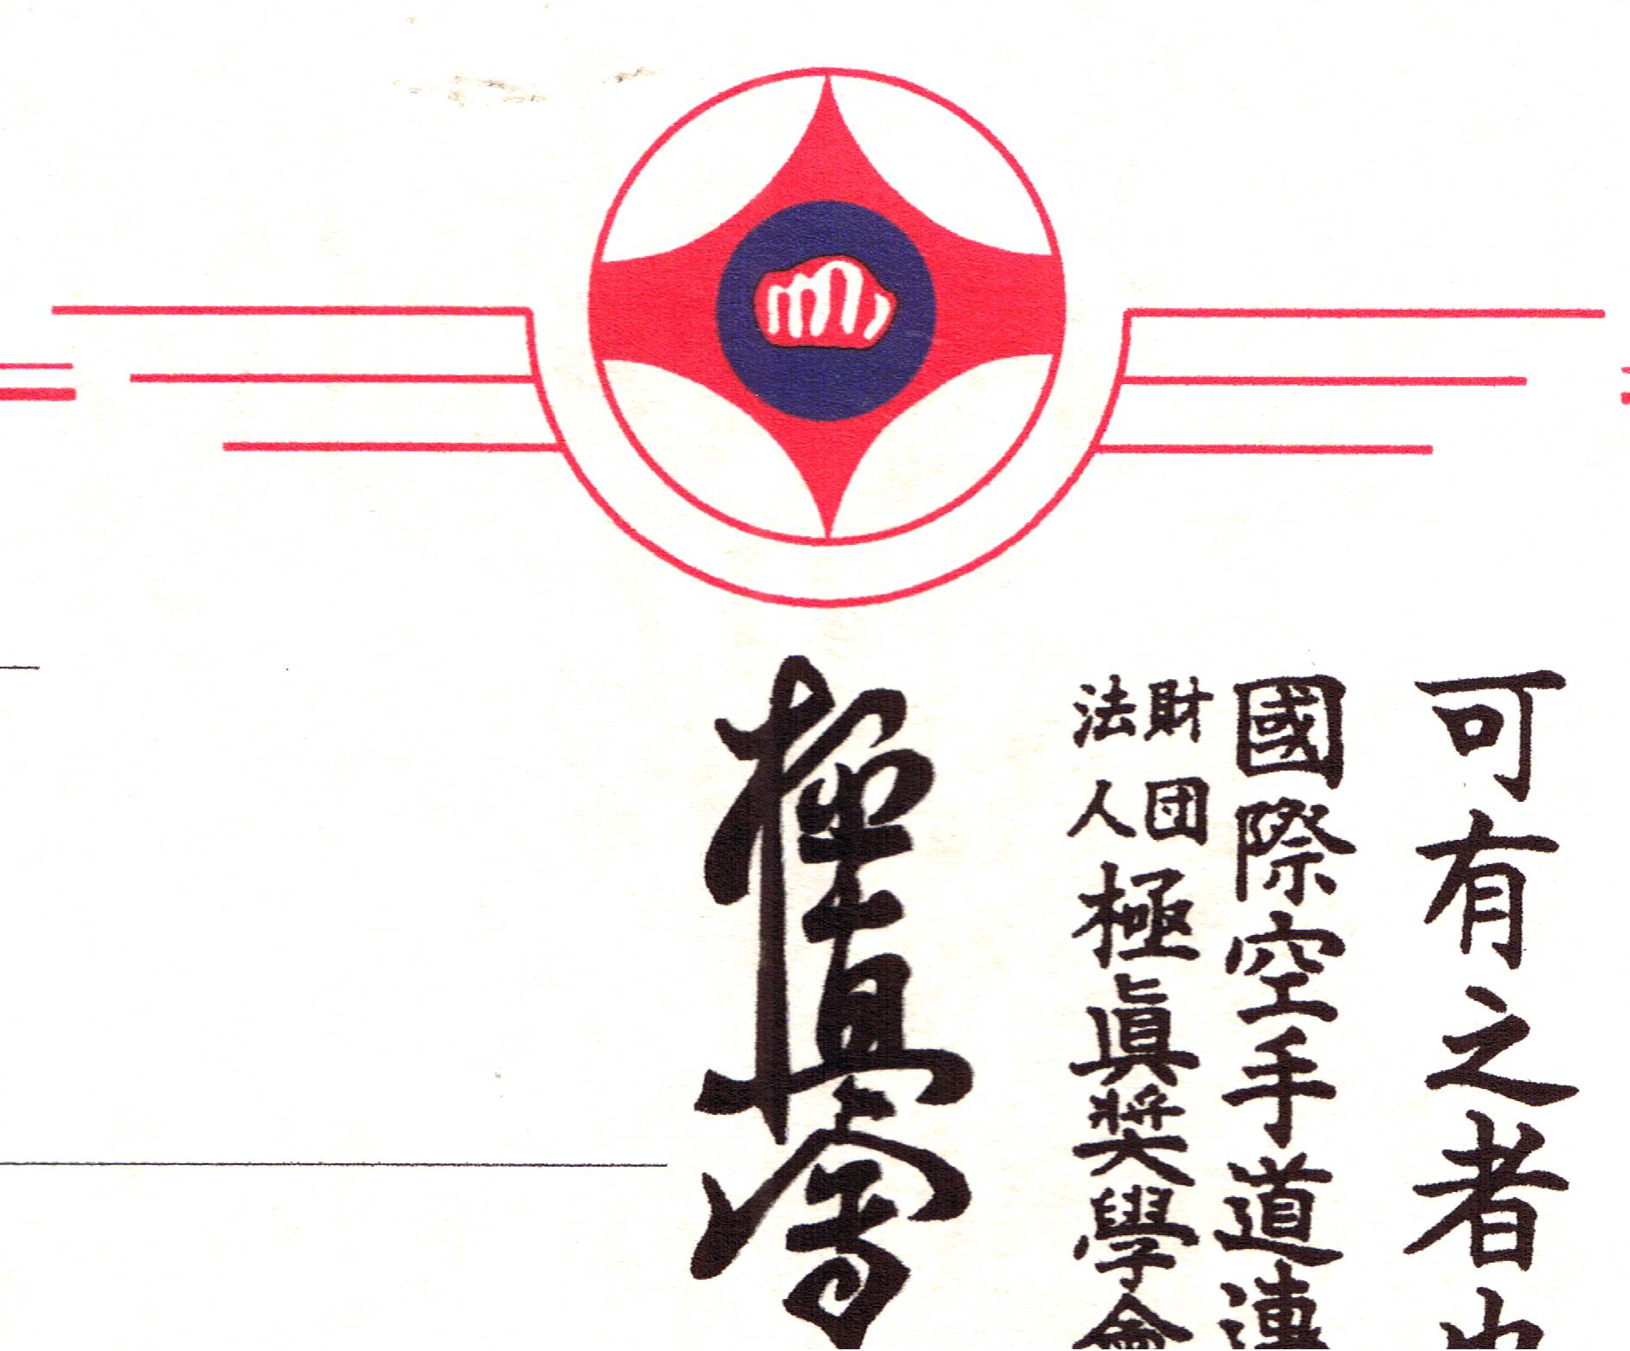

Hereby we have the honour to invite you to the

5th EUROPEAN CHAMPIONSHIPS
OF KYOKUSHIN RENGOKAI

Knock Down Tournament

- When: Saturday, 26th May 2012

- Where: Sportshal “PALAMAZZOLA”
TARANTO - Italy

- Categories:

KUMITE

Age group | Sex | Year of Birth |  | Event |  | Weight group  (kg) |  | Minimum grade
Junior | Male | 1994-1995 |  | Kyokushin kumite |  | OPEN |  | 6th kyu
Junior | Female | 1994-1995 |  | Kyokushin kumite |  | OPEN |  | 6th kyu
Adult | Male |  | up to 1993 |  | Kyokushin kumite |  | 70 / 80 / 90 / +90 |  | 4th kyu
Adult | Female |  | up to 1993 |  | Kyokushin kumite |  | OPEN |  | 4th kyu

KATA

Age group | Sex | Year of Birth |  | Event |  | Minimum grade
Adult | Male |  | up to 1993 |  | Kata |  | 4th kyu
Adult | Female |  | up to 1993 |  | Kata |  | 4th kyu

- Rules: International Kyokushin Karate Rules

- Protection: Juniors categories (until 18 years):
Boys: shin and groin protection;
Girl: shin and groin protection and breast protection (must be the cup type).
Adults categories:
Men: groin protection only.
Women: breast protection (must be the cup type), shin protection,
groin protection.

For other information contact me:

Sensei Francesco Fina
e.mail: oyamafitnessclub@libero.it
web site: www.kyokushin-kaikan.it

Subsequently I will send you all the other information.....

Hoping to hear from you, and looking forward to see you, and your fighters on the 26th of May 2012 in TARANTO - ITALY.

Respectful greetings.
You’re in kyokushin….
OSU…!!!
Sensei Francesco FINA

